🔥 Mastering Wildcards in Linux — A Simple Guide for Everyone
Wildcards in Linux — The Unsung Heroes of the Command Line
When you’re deep inside a Linux terminal, every second counts. Every command matters. Wildcards help you work faster, smarter, and with more control.
Wildcards in Linux are powerful symbols that help you match files, automate tasks, and work faster in the terminal. This styled guide explains each wildcard with clarity.

🌟 What Are Wildcards?
Wildcards are special symbols that let you match multiple files or patterns without typing full names.
They are used in commands like ls, cp, rm, mv, find, etc.
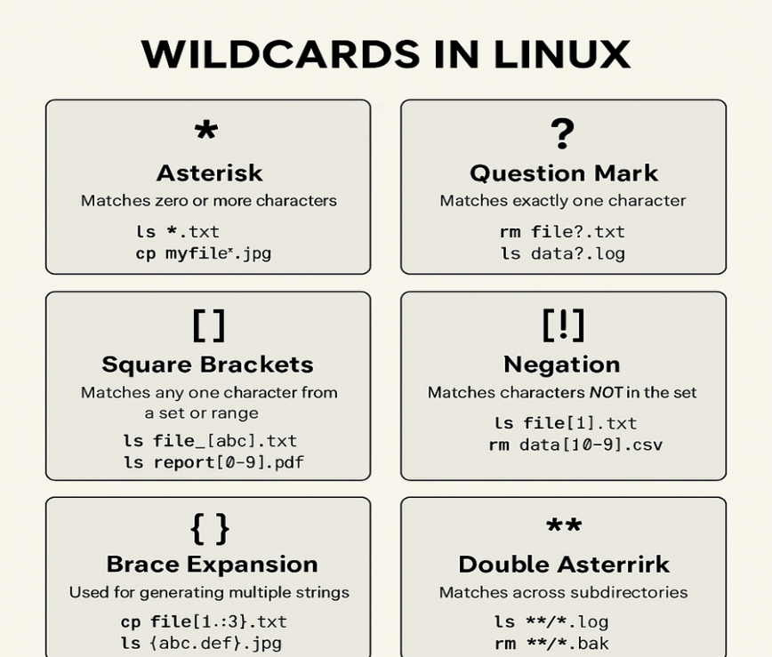

1. Asterisk (*) — The Infinite Match
Matches zero or more characters. Useful for selecting groups of files.
· Examples:
· ls *.txt
· rm test*
· cp * backup/

2. Question Mark (?) — One Character Match
Matches exactly one character. Offers precise pattern control.
· Examples:
· ls file?.log
· mv img?.png images/

3. Square Brackets [ ] — Set or Range
Matches a character from a defined set or numeric/letter range.
· Examples:
· ls report[1–5].pdf
· file[abc].txt

4. Negation [! ] — Match Anything Except
Matches characters NOT in the set. Perfect for exclusions.
· Examples:
· ls file[!1].txt
· log[!a-z].txt

5. Brace Expansion { } — Generate Strings
Creates multiple strings automatically — a powerful shortcut.
· Examples:
· touch file{1..5}.txt
· cp report{A,B,C}.pdf backup/
Ex:- touch file_{1..3}.txt
# Output: file_1.txt file_2.txt file_3.txt

6. Double Asterisk (**) — Recursive Match
Searches directories recursively for matching patterns.
· Examples:
· ls **/*.log
· rm **/*.tmp
Note: To use **, you may need to enable globstar in Bash
command :- shopt -s globstar

Why Wildcards Matter
Because in Linux, speed is survival.
Accuracy is power.
And mastery of small things leads to extraordinary control.
Wildcards aren’t just symbols
They’re how you bend the filesystem to your will.
They turn you from a beginner…
into a command-line warrior.

Final Takeaway
Wildcards may look small, but they are incredibly powerful tools in the Linux shell.
Once you start using them, you’ll never go back to typing long file names manually.

